Steven Thaw

sjthaw@me.com

Abstract

A Simple ATM Program using a graphical user interface.

atm program project 2

CMIS242 Intermediate Programming

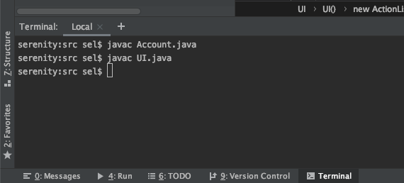

Figure Successful Compilation of Code

**Deposit/Withdrawl in Normal Situations**

|  |  |  |  |
| --- | --- | --- | --- |
| Test Case | Input | Expected Output | Pass/Fail |
| 1: Deposit Checking | 100 | Deposit to Checking Successful | Pass |
| 2: Deposit Savings | 100 | Deposit to Savings Successful | Pass |
| 3: Withdrawl Checking | 40 | Withdrawl from Checking Successful | Pass |
| 4: Withdrawl Savings | 20 | Withdrawl from Savings Successful | Pass |
| 5: Balance Checking | (Balance button clicked with checking radio button selected) | 60.0 | Pass |
| 6: Balance Savings | (Balance button clicked with savings radio button selected) | 80.0 | Pass |

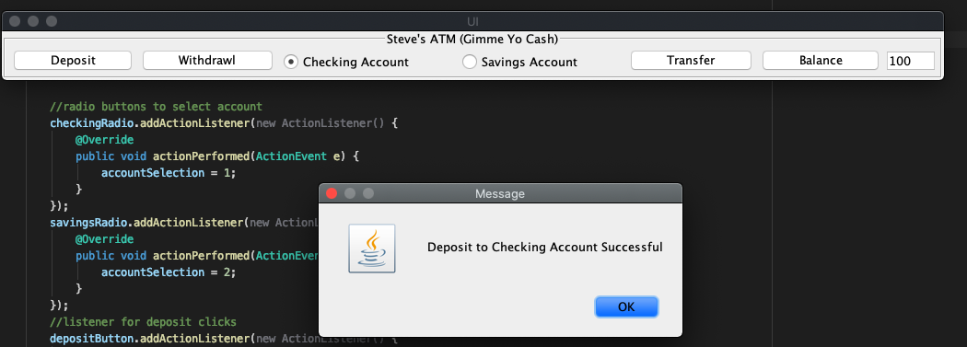

Figure Test Case 1 Deposit to Checking

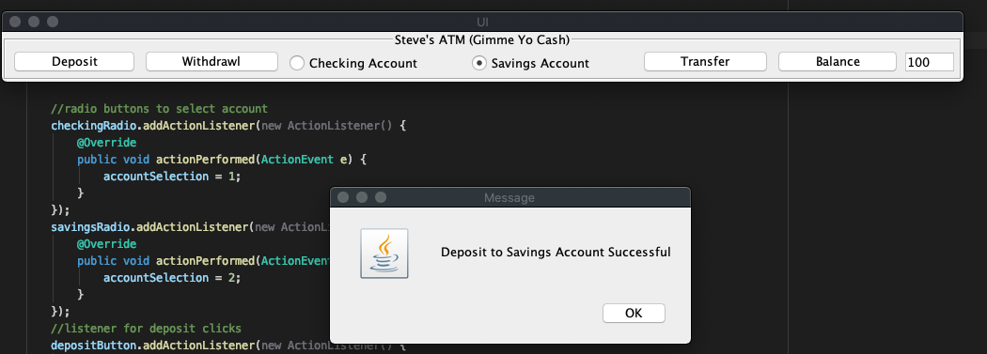

Figure Test Case 2 Deposit to Savings

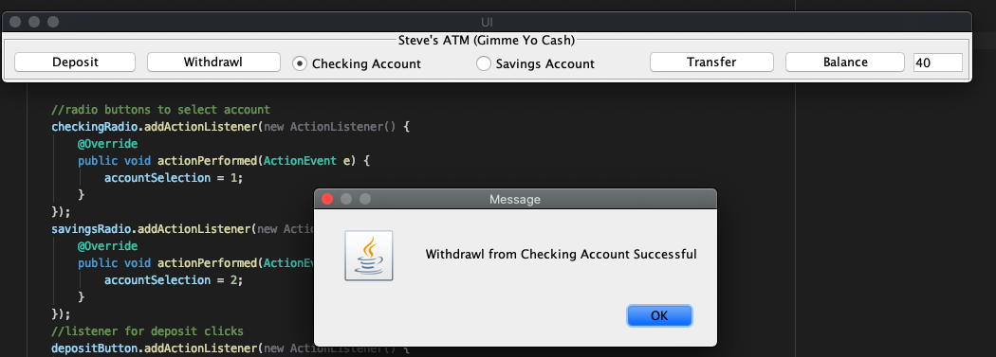

Figure Test Case 3 Withdrawl from Checking

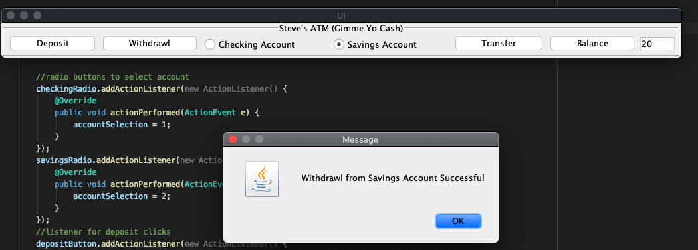

Figure Test Case 4 Withdrawl from Savings

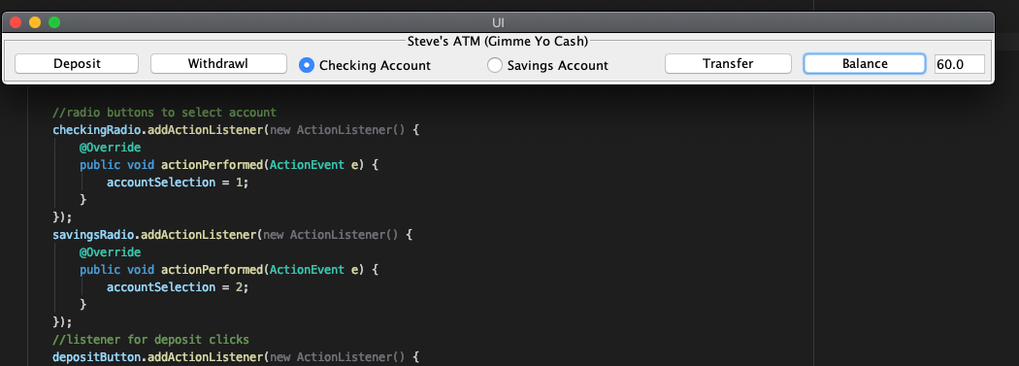

Figure Test Case 5 Balance of Checking

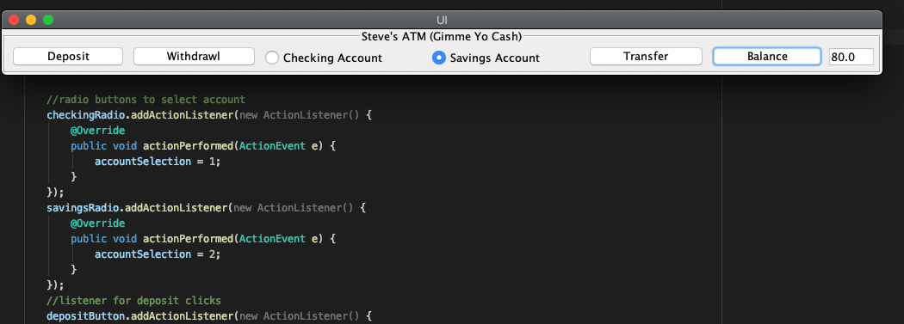

Figure Test Case 6 Balance of Savings

**Transfer and Transaction Fee Test Cases and Balances**

|  |  |  |  |
| --- | --- | --- | --- |
| Test Case | Input | Expected Output | Pass/Fail |
| 7: Transfer from Checking | 40 (checking radio selected, transfer button clicked) | Transfer to Savings Successful | Pass |
| 8: Transfer from Savings | 20 (savings radio selected, transfer button clicked) | Transfer to Checking Successful | Pass |
| 9: Balance of Checking | (Checking radio selected, balance button clicked) | 40.0 | Pass |
| 10: Balance of Savings | (Savings radio selected, balance button clicked) | 100.0 | Pass |
| 11: Attempt to Transfer Insufficient Funts | 60 (checking radio selected, transfer button clicked) | Insufficient Funds | Pass |

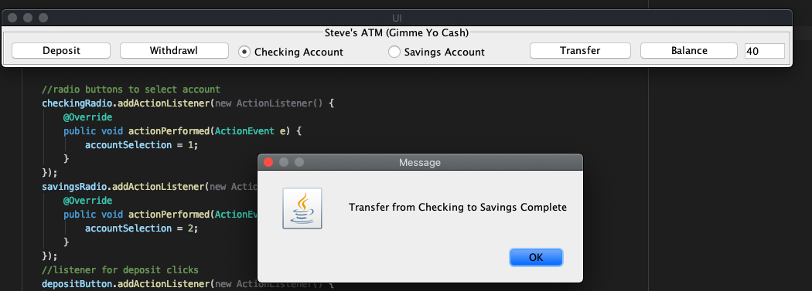

Figure Test Case 7 Transfer From Checking

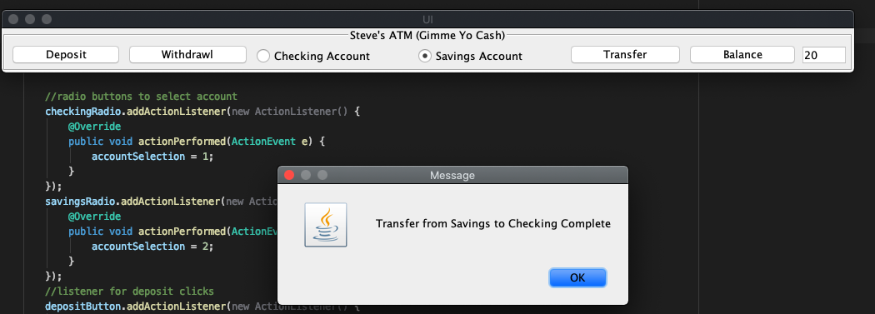

Figure Test Case 8 Transfer From Savings

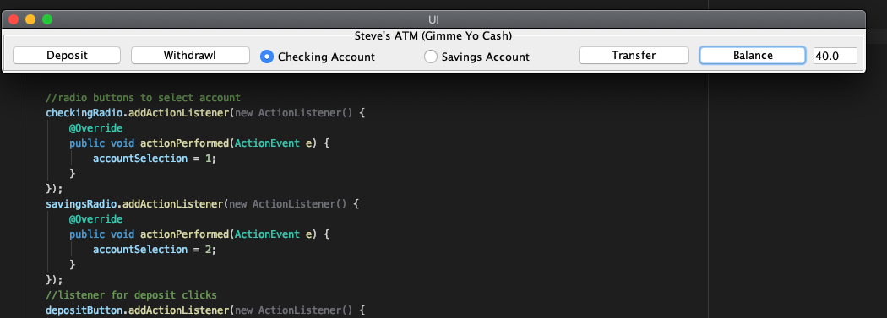

Figure Test Case 9 Balance of Checking After Transfer

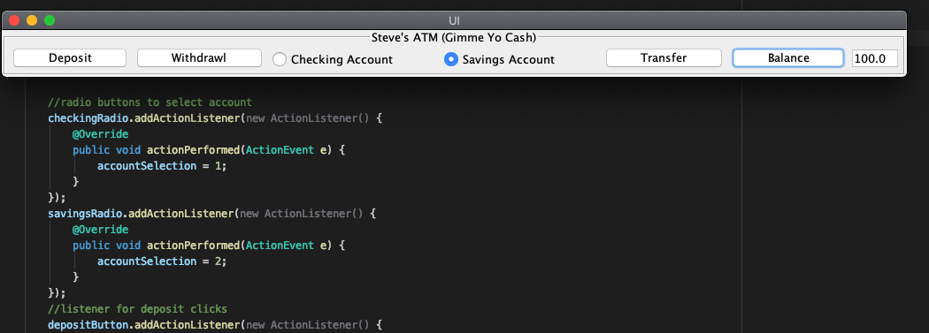

Figure Test Case 10 Balance of Savings After Transfer

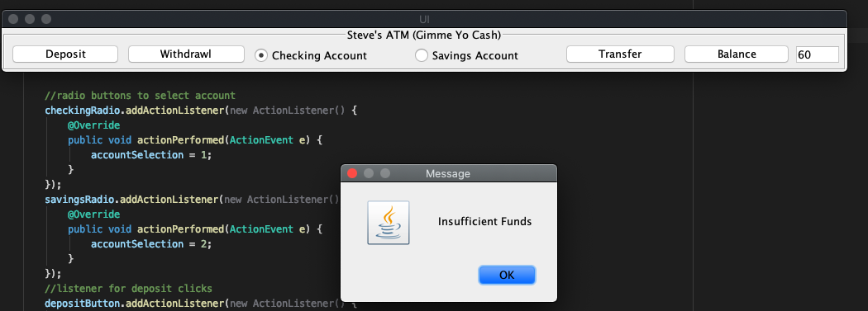

Figure Test Case 11 Attempt to Transfer Insufficient Funds

**Abnormal Situations (Deposit Negative Number, Insufficient Funds, Transaction Fee)**

|  |  |  |  |
| --- | --- | --- | --- |
| Test Case | Input | Expected Output | Pass/Fail |
| 12: Deposit Negative Number | -20 (checking radio selected, deposit button clicked) | Deposit value must be greater than $0 | Pass |
| 13: Withdrawl Insufficient Funds | 100 (checking radio selected, withdrawl button clicked) | Insufficient Funds | Pass |
| 14: Transaction Fee | 40 (savings radio selected, withdrawl button clicked) | Withdrawl from Savings Account Successful  Transaction Fee Charged | Pass |

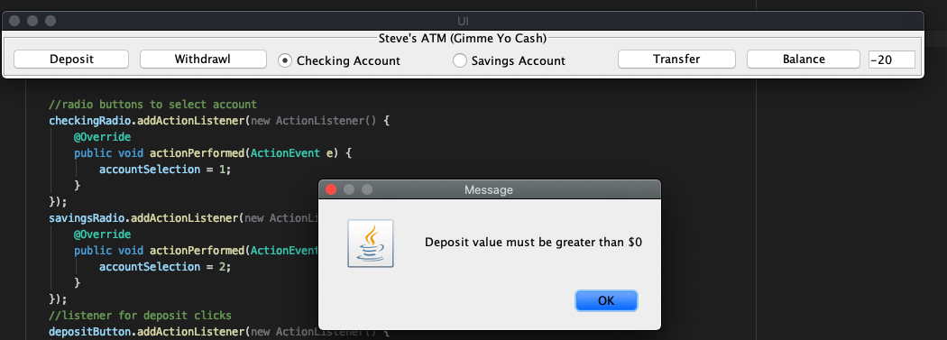

Figure Test Case 12 Deposit Negative Number

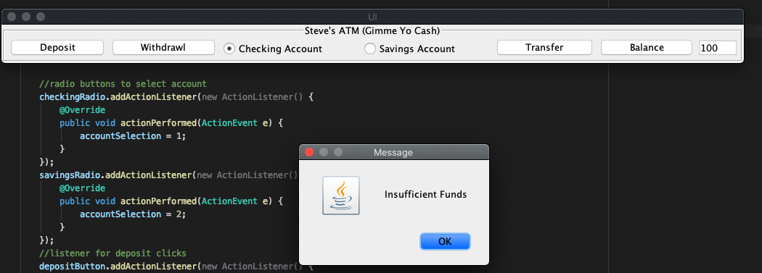

Figure Test Case 13 Withdrawl Insufficient Funds

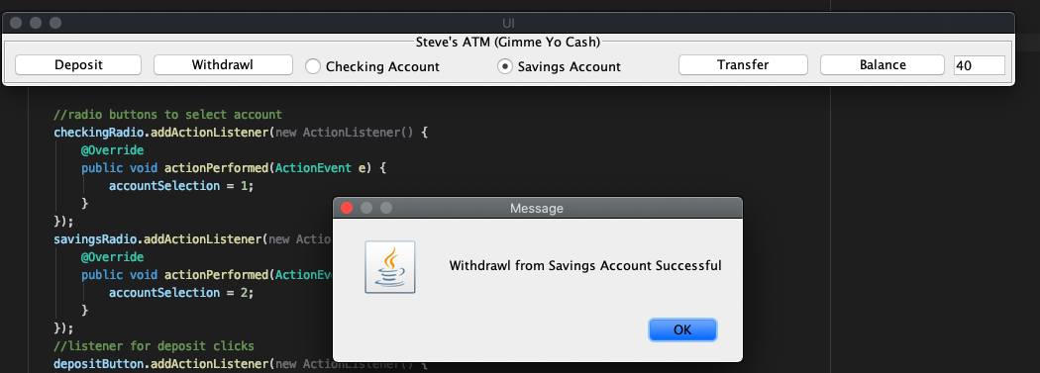

Figure Test Case 14 Transaction Fee Test

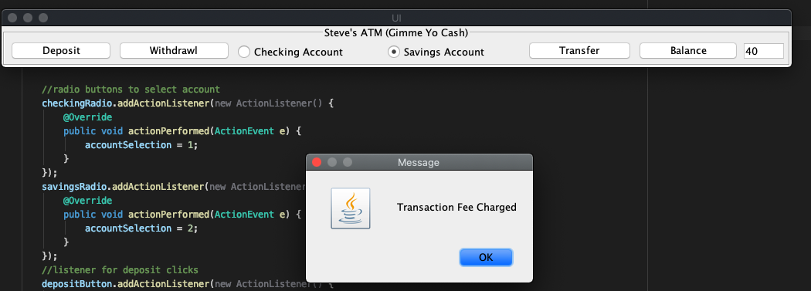

Figure Test Case 14 Transaction Fee Applied